Parish Ponds – Residents’ Consultation
Best wishes to all Residents for 2021.
Can we ask for your help please in answering a few questions about the Parish Ponds?
Background;
In Woolsington Parish we have a wonderful community asset in the shape of the Parish Ponds. The Parish Council wishes to make further improvements to this area, enhancing biodiversity and improving access.
The Ponds are located immediately south of the Ouseburn, about 200 metres west of the A696, they are in the centre of the Parish, on the boundary of the Callerton and Woolsington Wards.
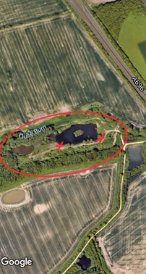
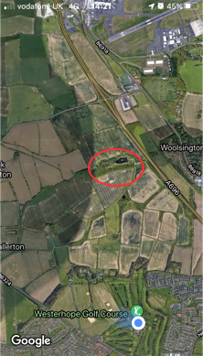

Fig.1 Location of Ponds Fig.2 Zoomed in view of main pond

The Ponds are enjoyed extensively by people from all areas of the Parish Community for all kinds of recreational purposes; walking, cycling, picnics, some fishing.
They were developed in the early 1990s following opencast work. Planning was gained from these works for leisure, for shelterbelts, bridleways, planting and ponds.
Over the intervening years the development has matured and has become a valued recreational place for many.

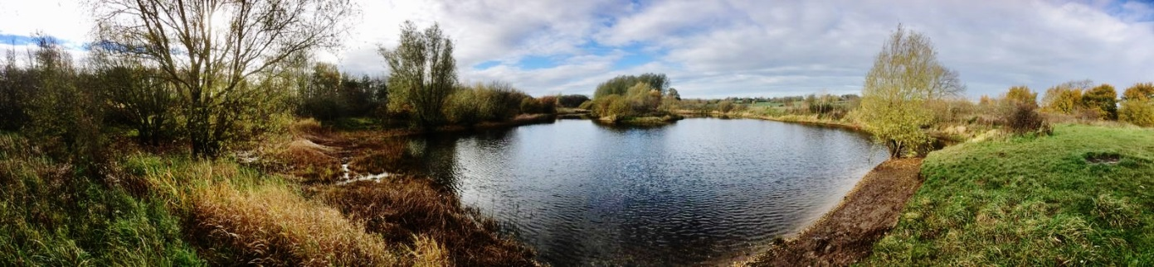

Fig 3 Panoramic view taken from the spot marked by red cross on right in Fig 2

The first phase of this project will be to remove an invasive plant called Water Soldier from the main pond. We are hoping that, pending approvals, this work may happen in summer 2021, when the plant is visible. It dies back in the winter months (see images below). As a result, the water quality should improve and the pond will be re-oxygenated, which in turn will benefit wildlife.
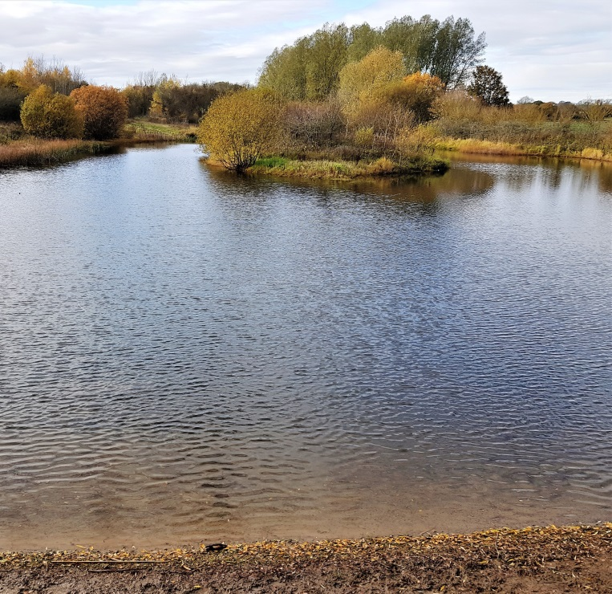
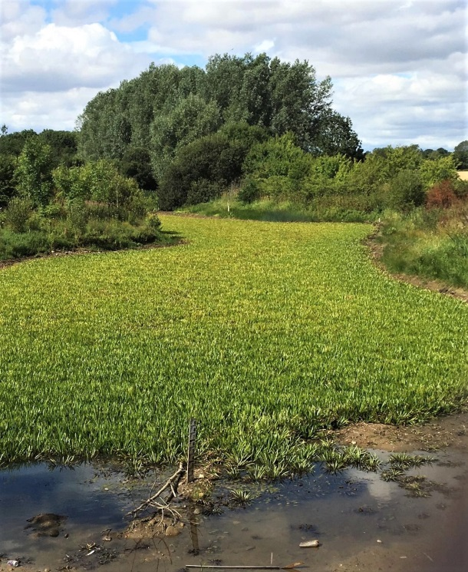

Fig.4 Pond after die-back of Water Soldier in November Fig 5 Same pond in July, Water
Soldier visible

The subsequent phases are larger in scope and we are seeking residents’ views, thinking not just of the ponds themselves but of the whole surrounding area and bridleway.
The views of the local community are extremely important and valued.
Therefore, it would be very helpful for the shaping of any future development if you could give your views on the following – please note any comments will be treated in confidence.
Please email your views to joannecouchman@yahoo.co.uk
Thank you
Parish Ponds – Residents’ Questionnaire

1. Did you know about the Parish Ponds area? YES / NO

2. Do you visit the Parish Ponds?

3. If yes, what do you like about the area?

4. Would you like to see the area improved and if so, how?

5. Have you any other comments or suggestions?

Thank you for your time, we appreciate it
Best wishes
Councillors John Littleton & Joanne Couchman

Jal/JC 21.12.20

